Git-HOL Exercise 5:
Steps:
-Verify main is clean:
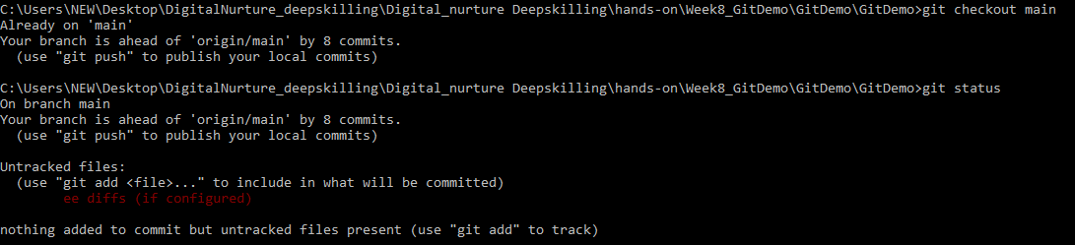
-List branches (local + remote)
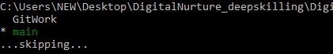
-Pull latest from remote main
-Push any pending changes to remote
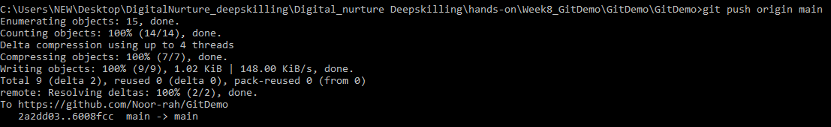
OUTPUT:
Observe Changes in remote repository:
